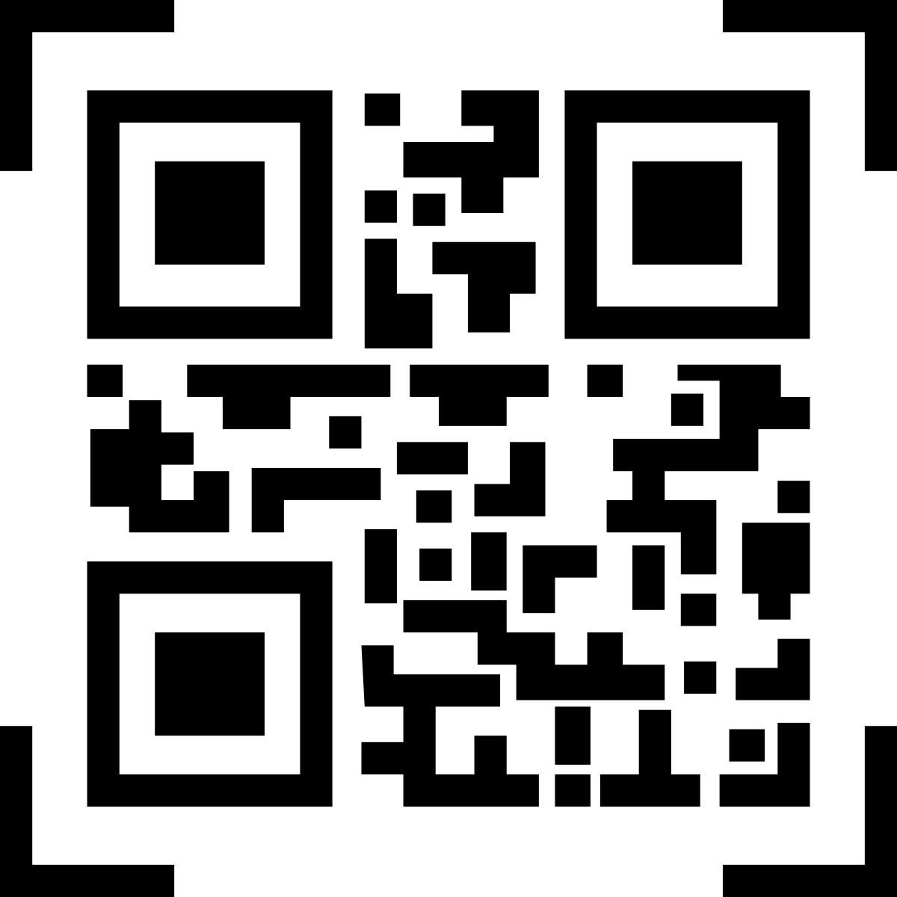

Name:

Marsha Williams

Father Name:

James Williams

ID Number:

SCH-1234-567

Terms & Conditions

* Lorem ipsum dolor sit amet, consectetur adipiscing elit, sed do eiusmod tempor
* Incididunt ut labore et dolore magna aliqua.
* Ullamco laboris nisi ut aliquip ex ea commodo consequat

Signature Authority

*Principal*



123 street address, City State, Zip Code

email@OfficeTemplatesOnline.com

123-456-7890, 444-555-COMP

https://www.OfficeTemplatesOnline.com

This Card is Valid Until

March 15, 2022