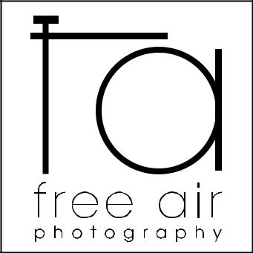
client information form

name :

email :

home

phone : cell

mailing address:

preferred method of contact: call |  | text | email
what kind of photo shoot are you booking?
maternity | child |  | couple
newborn | high school senior |  | wedding

snail mail | facebook

family

pets

who is going to be in your photo shoot? please list all the names below:

(please specify gender and age for each child and what type of animal if pets are included in your session)

desired session date : desired session time:

desired session location :

a $50 non-refundable deposit is due at the time you make your appointment.

cash | check please make all checks payable to your photographer, Erika Bresee

I hereby give Free Air Photography permission to use images from this and any portrait sessions for possible forms of advertisement to promote the photographer’s name or business. I confirm that I have legal authority to grant these permissions for myself and the included minor children.

signature : |  | date :
signature : |  | date :

parent/guardian signature required for clients under 18

additional information

are you a facebook user? if so, you may fill out the information below so i can easily find your profile. i will add you as a friend, then tag you with images from your recent session. If you prefer not to be tagged on facebook, leave this portion blank.

name used on facebook profile:

email address used:

what kinds of products are you interested in?

prints | digital images | photobooks/albums
canvas wraps | dvd slideshows | cards/announcements

how did you hear about free air photography?

google search

facebook

friend/relative

other:

if you were referred by someone, whom may i thank? :

addtional comments:
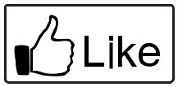

like free air photography on facebook
and get a free 8x10 print
from your photo shoot!

get $25 off your next photo shoot session fee
when you refer a friend to
free air photography!
(refer 4 friends and your next session is free!)

*referrals must result in booking a session

www.freeairphotography.com

