EMPLOYEE INFORMATION SHEET

COMPANY NAME:_________________________________________________________________________________

EMPLOYEE NAME:_________________________________________________________________________________

First

Middle

Last

ADDRESS: ________________________________CITY:___________________ STATE: ______ ZIP: ______________

SOCIAL SECURITY #: ___ ___ ___-___ ___ -___ ___ ___ ___ PHONE: (__ __ __) __ __ __- __ __ __ __

FOR PENNSYLVANIA EMPLOYERS ONLY.

THE FOLLOWING INFORMATION IS TAKEN FROM THE PA LOCAL EARNED INCOME TAX RESIDENCY CERTIFICATION FORM

 | EMPLOYEE RESIDENCE IS LOCATED IN: |  |  |  |  | TOWNSHIP or BORO: ____________________________________
 | PSD CODE ___ ___ ___ ___ ___ ___ It is the employer’s responsibility to provide the proper PSD Code for each employee.
 |  |  | This can be found at http://munstatspa.dced.state.pa.us/FindLocalTax.aspx
 | EMPLOYEE #__________ DEPT NAME__________________________ DEPT #________ |  |  |  |  |  |  |  |  |  |  |  |  |  |  | JOB #___________
 |  | (If applicable) |  |  |  |  |  | (If applicable) |  |  |  |  |  | (If applicable) |  |  |  | (If applicable)
 | JOB POSITION: ______________________________________________________
 | HOURLY RATE $ ______________ / houror |  |  |  |  |  | SALARY AMOUNT $ __________________ / per pay period
 |  |  |  |  |  |  |  | (Please provide per pay period amount, NOT annual amount)
 | IS OVERTIME CALCULATED AT 1.5 TIMES THE REGULAR RATE ? ____Yes ____No
 | FEDERAL WITHHOLDING STATUS: (W-4 information)
 | ___ SINGLE ____ MARRIED |  | ____ MARRIED But Withhold at Higher Single Rate
 | # OF EXEMPTIONS_______
 |  |  | (If ADDITIONAL AMOUNT $_________ |  |  |  |  |  |  |  |  | FLAT AMOUNT $__________ |  |  |  | FLAT %________ )
 | HIRE DATE: ___ ___/___ ___/ ___ ___ ___ ___ |  |  |  |  |  | BIRTH DATE: ___ ___/___ ___/ ___ ___ ___ ___ |  |  |  |  |  |  |  |  |  | Gender ________
 | Required |  |  |  |  |  | Required
 | LOCAL SERVICES TAX (LST) : If you are required to pay LST (formerly EMST ) Tax.
 | Have you filed an up-front exemption certificate with your employer and local municipality? ____Yes |  |  |  |  |  |  |  |  |  |  |  |  |  |  |  | ____No
 | If “YES”, indicate the reason? |  | _________
 | P – Primary employer is deducting |  | L – Low earnings (under $ 12,000/year) M – Military Active D – Disabled Military

VOLUNTARY DEDUCTIONS (Deductions other than taxes)

If employee has any garnishment / attachment, please supply copy of the Court Order / Documentation.

DEDUCTION | AMOUNT | DEDUCTION | AMOUNT
NAME | PER PAY PERIOD | NAME | PER PAY PERIOD
1.__________________ | __________________ | 4.___________________ | ___________________
2.__________________ | __________________ | 5.___________________ | ___________________
3.__________________ | __________________ | 6.___________________ | ___________________

JetPay Payroll Services | Stabler Corporate Center | 3939 West Drive | Center Valley, PA 18034
610.797.9500 | Fax: 610.797.9520 | 1-800-DO-MY-PAY® (366-9729)

Form W-4 (2016)

Purpose. Complete Form W-4 so that your employer
can withhold the correct federal income tax from your
pay. Consider completing a new Form W-4 each year
and when your personal or financial situation changes.

Exemption from withholding. If you are exempt, complete only lines 1, 2, 3, 4, and 7 and sign the form to validate it. Your exemption for 2016 expires February 15, 2017. See Pub. 505, Tax Withholding and Estimated Tax.

Note: If another person can claim you as a dependent on his or her tax return, you cannot claim exemption from withholding if your income exceeds $1,050 and includes more than $350 of unearned income (for example, interest and dividends).

Exceptions. An employee may be able to claim exemption from withholding even if the employee is a dependent, if the employee:

- Is age 65 or older,

- Is blind, or

- Will claim adjustments to income; tax credits; or itemized deductions, on his or her tax return.

The exceptions do not apply to supplemental wages greater than $1,000,000.

Basic instructions. If you are not exempt, complete the Personal Allowances Worksheet below. The worksheets on page 2 further adjust your withholding allowances based on itemized deductions, certain credits, adjustments to income, or two-earners/multiple jobs situations.

Complete all worksheets that apply. However, you may claim fewer (or zero) allowances. For regular wages, withholding must be based on allowances you claimed and may not be a flat amount or percentage of wages.

Head of household. Generally, you can claim head of household filing status on your tax return only if you are unmarried and pay more than 50% of the costs of keeping up a home for yourself and your dependent(s) or other qualifying individuals. See Pub. 501, Exemptions, Standard Deduction, and Filing Information, for information.

Tax credits. You can take projected tax credits into account in figuring your allowable number of withholding allowances. Credits for child or dependent care expenses and the child tax credit may be claimed using the Personal Allowances Worksheet below. See Pub. 505 for information on converting your other credits into withholding allowances.

Nonwage income. If you have a large amount of nonwage income, such as interest or dividends, consider making estimated tax payments using Form 1040-ES, Estimated Tax for Individuals. Otherwise, you may owe additional tax. If you have pension or annuity income, see Pub. 505 to find out if you should adjust your withholding on Form W-4 or W-4P.

Two earners or multiple jobs. If you have a working spouse or more than one job, figure the total number of allowances you are entitled to claim on all jobs using worksheets from only one Form W-4. Your withholding usually will be most accurate when all allowances are claimed on the Form W-4 for the highest paying job and zero allowances are claimed on the others. See Pub. 505 for details.

Nonresident alien. If you are a nonresident alien, see Notice 1392, Supplemental Form W-4 Instructions for Nonresident Aliens, before completing this form.

Check your withholding. After your Form W-4 takes effect, use Pub. 505 to see how the amount you are having withheld compares to your projected total tax for 2016. See Pub. 505, especially if your earnings exceed $130,000 (Single) or $180,000 (Married).

Future developments. Information about any future developments affecting Form W-4 (such as legislation enacted after we release it) will be posted at www.irs.gov/w4.

Personal Allowances Worksheet (Keep for your records.)

A | Enter “1” for yourself if no one else can claim you as a dependent . . . . . . . . . |  | . . . . . . . . . | A
 | Enter “1” if: { | • You are single and have only one job; or | } . . .
B |  | • You are married, have only one job, and your spouse does not work; or |  | B

• Your wages from a second job or your spouse’s wages (or the total of both) are $1,500 or less.

- Enter “1” for your spouse. But, you may choose to enter “-0-” if you are married and have either a working spouse or more

 | than one job. (Entering “-0-” may help you avoid having too little tax withheld.) . . . . . . . . . . . . . . | C
D | Enter number of dependents (other than your spouse or yourself) you will claim on your tax return . . . . . . . . | D
E | Enter “1” if you will file as head of household on your tax return (see conditions under Head of household above) . . | E
F | Enter “1” if you have at least $2,000 of child or dependent care expenses for which you plan to claim a credit . . . | F
 | (Note: Do not include child support payments. See Pub. 503, Child and Dependent Care Expenses, for details.)

- Child Tax Credit (including additional child tax credit). See Pub. 972, Child Tax Credit, for more information.

• If your total income will be less than $70,000 ($100,000 if married), enter “2” for each eligible child; then less “1” if you have two to four eligible children or less “2” if you have five or more eligible children.

• If your total income will be between $70,000 and $84,000 ($100,000 and $119,000 if married), enter “1” for each eligible child . . G

- Add lines A through G and enter total here. (Note: This may be different from the number of exemptions you claim on your tax return.) ▶ H

For accuracy, | { | • If you plan to itemize or claim adjustments to income and want to reduce your withholding, see the Deductions
 |  | and Adjustments Worksheet on page 2.
complete all |  | • If you are single and have more than one job or are married and you and your spouse both work and the | combined
worksheets
 |  | earnings from all jobs exceed $50,000 ($20,000 if married), see the Two-Earners/Multiple Jobs Worksheet on | page 2
that apply. |  | to avoid having too little tax withheld.
- If neither of the above situations applies, stop here and enter the number from line H on line 5 of Form W-4 below.

Separate here and give Form W-4 to your employer. Keep the top part for your records.

Form W-4

Department of the Treasury Internal Revenue Service

Employee's Withholding Allowance Certificate | OMB No. 1545-0074
▶ Whether you are entitled to claim a certain number of allowances or exemption from withholding is | 2016
subject to review by the IRS. Your employer may be required to send a copy of this form to the IRS.

1 | Your first name and middle initial | Last name |  |  |  |  | 2 Your social security number
 | Home address (number and street or rural route) |  | 3 | Single | Married | Married, but withhold at higher Single rate.
 |  |  | Note: If married, but legally separated, or spouse is a nonresident alien, check the “Single” box.
 | City or town, state, and ZIP code |  | 4 | If your last name differs from that shown on your social security card,
 |  |  |  | check here. You must call 1-800-772-1213 for a replacement card. ▶
5 | Total number of allowances you are claiming (from line H above or from the applicable worksheet on page 2) |  |  |  |  |  |  | 5
6 | Additional amount, if any, you want withheld from each paycheck |  |  | . . . . | . . . . | . . . . . . |  | 6 | $

- I claim exemption from withholding for 2016, and I certify that I meet both of the following conditions for exemption.

  - Last year I had a right to a refund of all federal income tax withheld because I had no tax liability, and

  - This year I expect a refund of all federal income tax withheld because I expect to have no tax liability.

If you meet both conditions, write “Exempt” here . . . . . . . . . . . . . . . ▶ 7

Under penalties of perjury, I declare that I have examined this certificate and, to the best of my knowledge and belief, it is true, correct, and complete.

Employee’s signature
(This form is not valid unless you sign it.) ▶ |  |  | Date ▶
8 | Employer’s name and address (Employer: Complete lines 8 and 10 only if sending to the IRS.) | 9 Office code (optional) | 10 Employer identification number (EIN)
For Privacy Act and Paperwork Reduction Act Notice, see page 2. |  | Cat. No. 10220Q | Form W-4 (2016)

Form W-4 (2016) Page 2

Deductions and Adjustments Worksheet

Note: Use this worksheet only if you plan to itemize deductions or claim certain credits or adjustments to income.

- Enter an estimate of your 2016 itemized deductions. These include qualifying home mortgage interest, charitable contributions, state and local taxes, medical expenses in excess of 10% (7.5% if either you or your spouse was born before January 2, 1952) of your
 | income, and miscellaneous deductions. For 2016, you may have to reduce your itemized deductions if your income is over $311,300
 | and you are married filing jointly or are a qualifying widow(er); $285,350 if you are head of household; $259,400 if you are single and
 | not head of household or a qualifying widow(er); or $155,650 if you are married filing separately. See Pub. 505 for details . . . |  |  | 1 | $
 | Enter: { | $12,600 if married filing jointly or qualifying widow(er) | } . . . . . . . . . . .
2 |  | $9,300 if head of household |  | 2 | $
 |  | $6,300 if single or married filing separately
3 | Subtract line 2 from line 1. If zero or less, enter “-0-” . . . . . . . . . . . . . . . . |  |  | 3 | $
4 | Enter an estimate of your 2016 adjustments to income and any additional standard deduction (see Pub. 505) |  |  | 4 | $

- Add lines 3 and 4 and enter the total. (Include any amount for credits from the Converting Credits to

 | Withholding Allowances for 2016 Form W-4 worksheet in Pub. 505.) . . . . . . . . . . . . | 5 | $
6 | Enter an estimate of your 2016 nonwage income (such as dividends or interest) . . . . . . . . | 6 | $
7 | Subtract line 6 from line 5. If zero or less, enter “-0-” . . . . . . . . . . . . . . . . | 7 | $
8 | Divide the amount on line 7 by $4,050 and enter the result here. Drop any fraction . . . . . . . | 8
9 | Enter the number from the Personal Allowances Worksheet, line H, page 1 . . . . . . . . . | 9

- Add lines 8 and 9 and enter the total here. If you plan to use the Two-Earners/Multiple Jobs Worksheet,

also enter this total on line 1 below. Otherwise, stop here and enter this total on Form W-4, line 5, page 1 | 10

Two-Earners/Multiple Jobs Worksheet (See Two earners or multiple jobs on page 1.)

Note: Use this worksheet only if the instructions under line H on page 1 direct you here.

- Enter the number from line H, page 1 (or from line 10 above if you used the Deductions and Adjustments Worksheet)

- Find the number in Table 1 below that applies to the LOWEST paying job and enter it here. However, if

you are married filing jointly and wages from the highest paying job are $65,000 or less, do not enter more than “3” . . . . . . . . . . . . . . . . . . . . . . . . . . . . . .

- If line 1 is more than or equal to line 2, subtract line 2 from line 1. Enter the result here (if zero, enter “-0-”) and on Form W-4, line 5, page 1. Do not use the rest of this worksheet . . . . . . . . .

Note: If line 1 is less than line 2, enter “-0-” on Form W-4, line 5, page 1. Complete lines 4 through 9 below to

 | figure the additional withholding amount necessary to avoid a year-end tax bill.
4 | Enter the number from line 2 of this worksheet . . . . . . . . . . | 4
5 | Enter the number from line 1 of this worksheet . . . . . . . . . . | 5
6 | Subtract line 5 from line 4 . . . . . . . . . . . . . . . . . . . . . . . . .
7 | Find the amount in Table 2 below that applies to the HIGHEST paying job and enter it here . . . .
8 | Multiply line 7 by line 6 and enter the result here. This is the additional annual withholding needed . .

- Divide line 8 by the number of pay periods remaining in 2016. For example, divide by 25 if you are paid every two weeks and you complete this form on a date in January when there are 25 pay periods remaining in 2016. Enter the result here and on Form W-4, line 6, page 1. This is the additional amount to be withheld from each paycheck

1

2

3

6

- $

- $

- $

 |  |  |  | Table 1 |  |  |  |  |  |  |  |  | Table 2
 | Married Filing Jointly |  |  |  |  |  | All Others |  |  | Married Filing Jointly |  |  |  |  |  | All Others
 | If wages from LOWEST |  |  | Enter on | If wages from LOWEST |  |  |  | Enter on | If wages from HIGHEST |  |  | Enter on | If wages from HIGHEST |  |  |  | Enter on
 | paying job are— |  |  | line 2 above | paying job are— |  |  |  | line 2 above | paying job are— |  |  | line 7 above | paying job are— |  |  |  | line 7 above
 | $0 - |  | $6,000 | 0 | $0 - |  | $9,000 |  | 0 | $0 - |  | $75,000 | $610 | $0 - |  | $38,000 |  | $610
 | 6,001 | - | 14,000 | 1 | 9,001 | - | 17,000 |  | 1 | 75,001 | - | 135,000 | 1,010 | 38,001 | - | 85,000 |  | 1,010
 | 14,001 | - | 25,000 | 2 | 17,001 | - | 26,000 |  | 2 | 135,001 | - | 205,000 | 1,130 | 85,001 | - | 185,000 |  | 1,130
 | 25,001 | - | 27,000 | 3 | 26,001 | - | 34,000 |  | 3 | 205,001 | - | 360,000 | 1,340 | 185,001 | - | 400,000 |  | 1,340
 | 27,001 | - | 35,000 | 4 | 34,001 | - | 44,000 |  | 4 | 360,001 | - | 405,000 | 1,420 | 400,001 and over |  |  |  | 1,600
 | 35,001 | - | 44,000 | 5 | 44,001 | - | 75,000 |  | 5 | 405,001 and over |  |  | 1,600
 | 44,001 | - | 55,000 | 6 | 75,001 | - | 85,000 |  | 6
 | 55,001 | - | 65,000 | 7 | 85,001 | - | 110,000 |  | 7
 | 65,001 | - | 75,000 | 8 | 110,001 | - | 125,000 |  | 8
 | 75,001 | - | 80,000 | 9 | 125,001 | - | 140,000 |  | 9
 | 80,001 | - 100,000 |  | 10 | 140,001 and over |  |  |  | 10
 | 100,001 | - | 115,000 | 11
 | 115,001 | - | 130,000 | 12
 | 130,001 | - | 140,000 | 13
 | 140,001 | - | 150,000 | 14
 | 150,001 and over |  |  | 15

Privacy Act and Paperwork Reduction Act Notice. We ask for the information on this form to carry out the Internal Revenue laws of the United States. Internal Revenue Code sections 3402(f)(2) and 6109 and their regulations require you to provide this information; your employer uses it to determine your federal income tax withholding. Failure to provide a properly completed form will result in your being treated as a single person who claims no withholding allowances; providing fraudulent information may subject you to penalties. Routine uses of this information include giving it to the Department of Justice for civil and criminal litigation; to cities, states, the District of Columbia, and U.S. commonwealths and possessions for use in administering their tax laws; and to the Department of Health and Human Services for use in the National Directory of New Hires. We may also disclose this information to other countries under a tax treaty, to federal and state agencies to enforce federal nontax criminal laws, or to federal law enforcement and intelligence agencies to combat terrorism.

You are not required to provide the information requested on a form that is subject to the Paperwork Reduction Act unless the form displays a valid OMB control number. Books or records relating to a form or its instructions must be retained as long as their contents may become material in the administration of any Internal Revenue law. Generally, tax returns and return information are confidential, as required by Code section 6103.

The average time and expenses required to complete and file this form will vary depending on individual circumstances. For estimated averages, see the instructions for your income tax return.

If you have suggestions for making this form simpler, we would be happy to hear from you.
See the instructions for your income tax return.

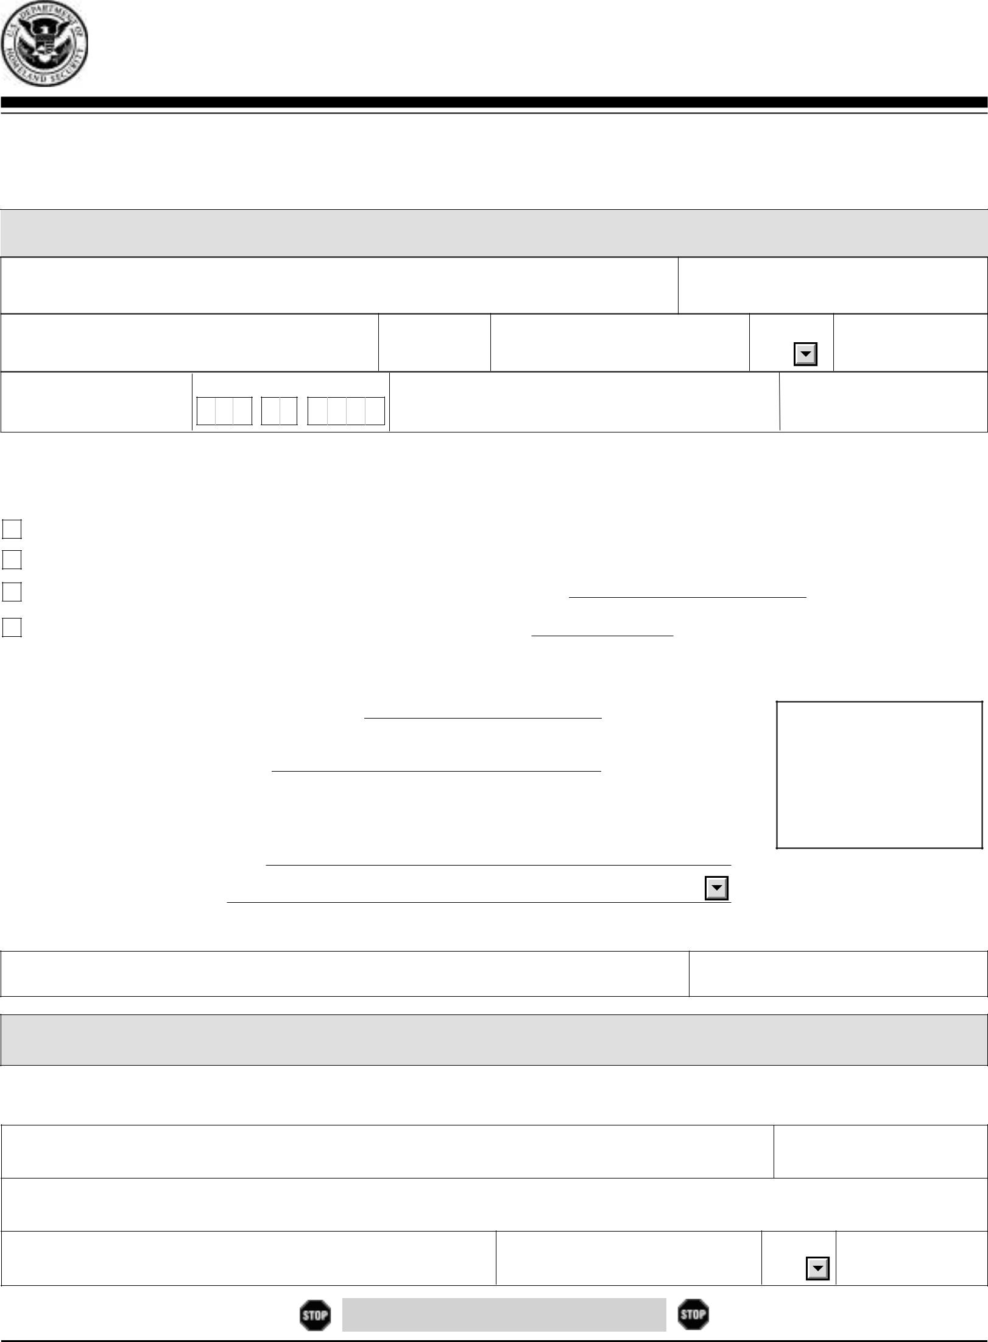

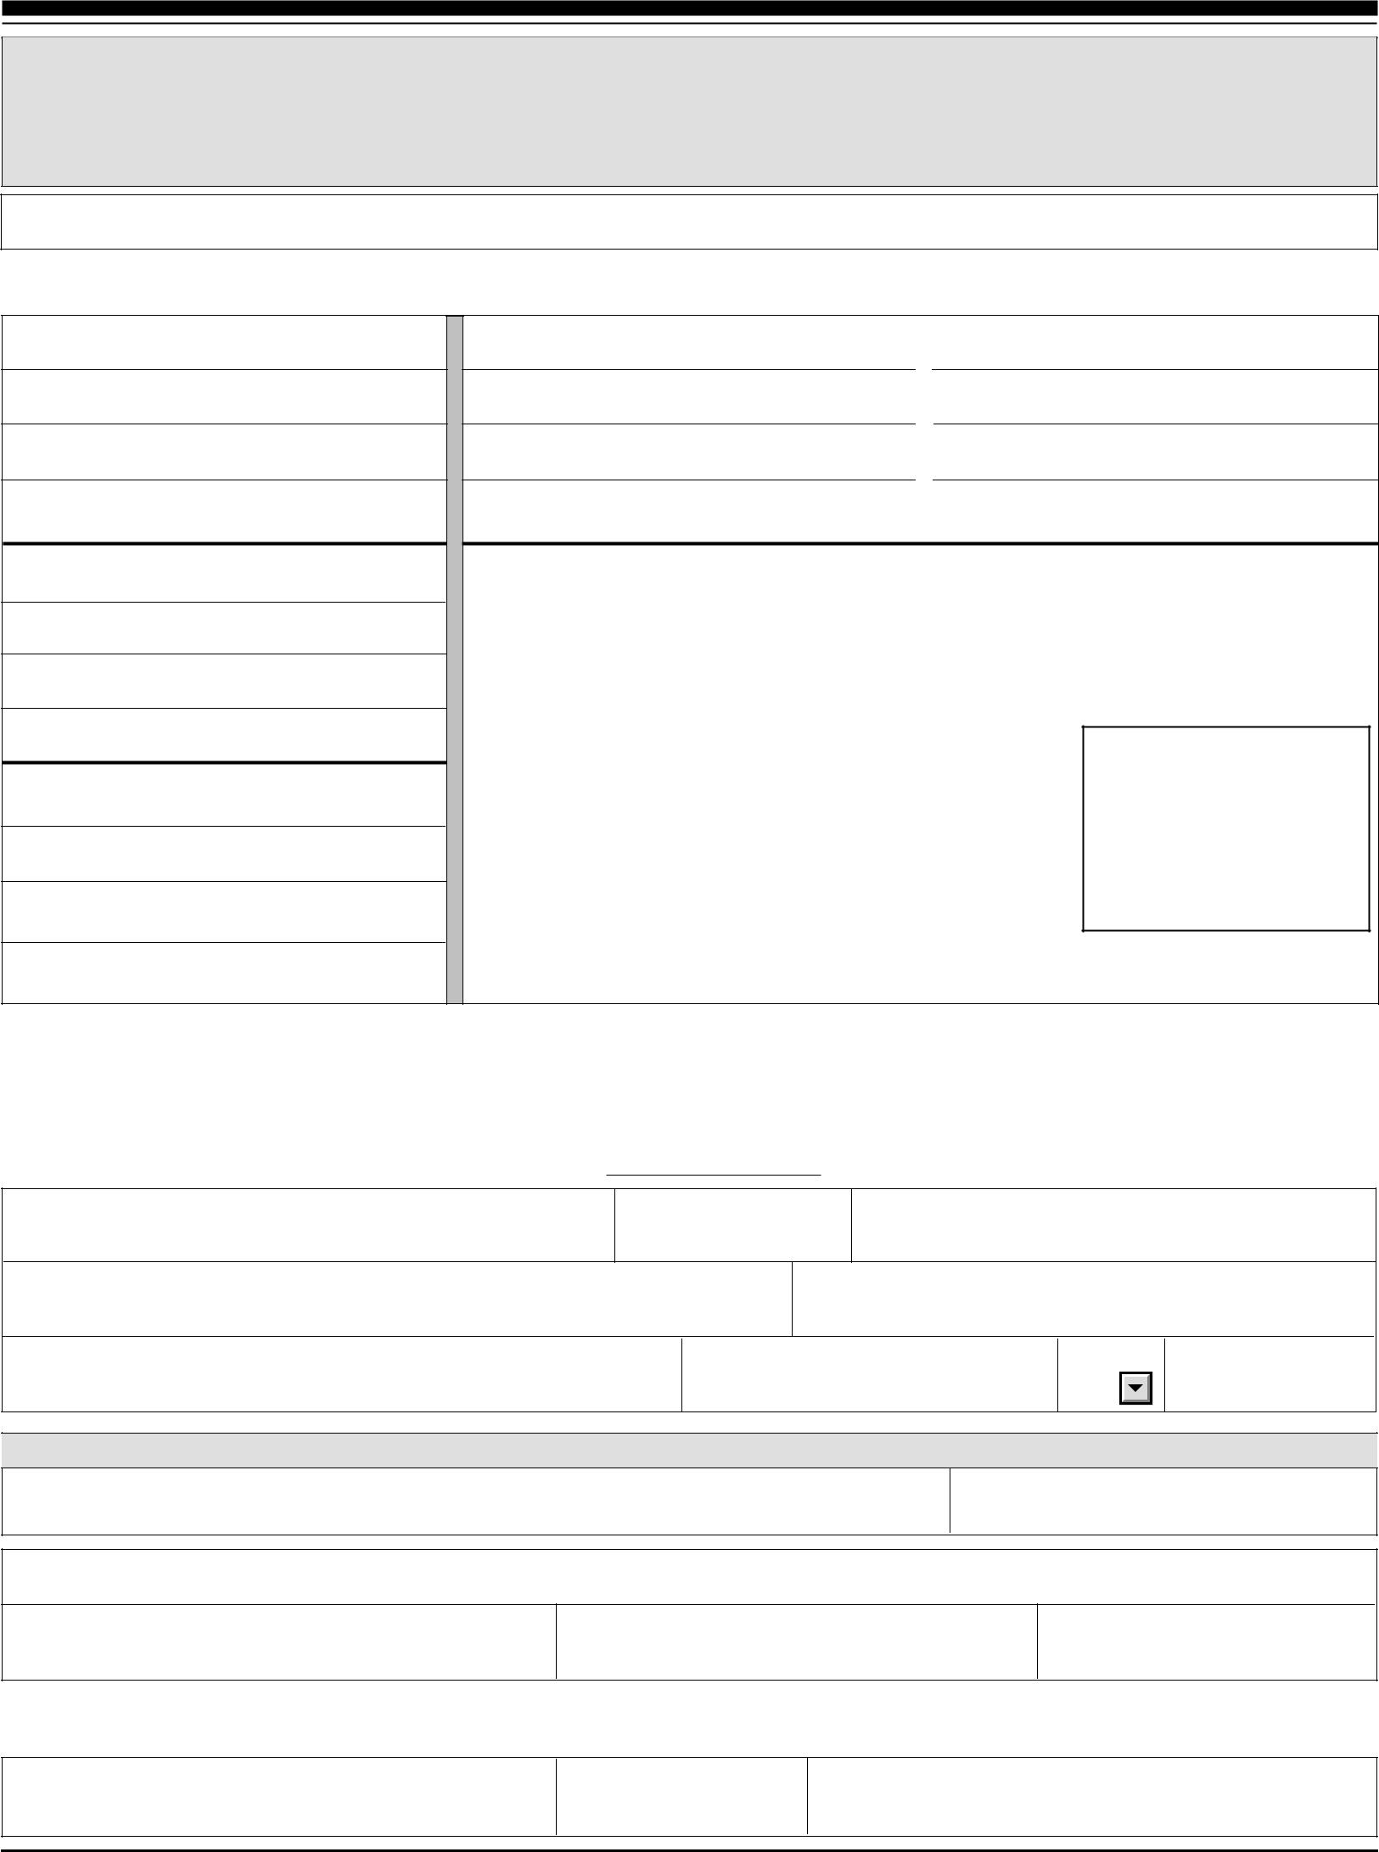

CLGS-32-6 (8-11)

RESIDENCY CERTIFICATION FORM
Local Earned Income Tax Withholding

TO EMPLOYERS/TAXPAYERS:

This form is to be used by employers and/or taxpayers to report essential information for the collection and distribution of Local Earned Income Taxes.

This form must be utilized by employers when a new employee is hired or when a current employee notifies employer of a name and/or address change.

EMPLOYEE INFORMATION - RESIDENCE LOCATION

NAME (Last Name, First Name, Middle Initial) |  |  | SOCIAL SECURITY NUMBER
STREET ADDRESS (No PO Box, RD or RR)
SECOND LINE OF ADDRESS
CITY | STATE | ZIP CODE | DAYTIME PHONE NUMBER
MUNICIPALITY (City, Borough or Township)
COUNTY | RESIDENT PSD CODE |  | TOTAL RESIDENT EIT RATE

EMPLOYER INFORMATION - EMPLOYMENT LOCATION

 | EMPLOYER BUSINESS NAME (Use Federal ID Name) | EMPLOYER FEIN

STREET ADDRESS WHERE ABOVE EMPLOYEE REPORTS TO WORK (No PO Box, RD or RR)

SECOND LINE OF ADDRESS

 | CITY | STATE | ZIP CODE |  | PHONE NUMBER
 | MUNICIPALITY (City, Borough or Township)
 | COUNTY | WORK LOCATION PSD CODE |  | WORK LOCATION NON-RESIDENT EIT RATE

CERTIFICATION

Under penalties of perjury, I (we) declare that I (we) have examined this information, including all accompanying
schedules and statements and to the best of my (our) belief, they are true, correct and complete.

 | SIGNATURE OF EMPLOYEE |  | DATE (MM/DD/YYYY)
 | PHONE NUMBER | EMAIL ADDRESS

For information on obtaining the appropriate MUNICIPALITY (City, Borough, Township), PSD CODES and EIT (Earned Income Tax) RATES, please refer to the Pennsylvania Department of Community & Economic Development website:

www.newPA.com

LOCAL SERVICES TAX – EXEMPTION CERTIFICATE

___________________________________________
Tax Year

APPLICATION FOR EXEMPTION FROM LOCAL SERVICES TAX

- A copy of this application for exemption from the Local Services Tax (LST), and all necessary supporting documents, must be completed and presented to your employer AND to the political subdivision levying the Local Services Tax where you are principally employed.
- This application for exemption from the Local Services Tax must be signed and dated.
- No exemption will be approved until proper documentation has been received.

Name: _____________________________________ Soc Sec #: ____________________________________

Address: ___________________________________ Phone #: _____________________________________
City/State: _________________________________ Zip: _________________________________________

 |  |  | REASON FOR EXEMPTION
1. | __________
 |  | MULTIPLE EMPLOYERS: Attach a copy of a current pay statement from your principal
 |  | employer that shows the name of the employer, the length of the payroll period and the amount of
 |  | Local Services Tax withheld. List all employers on the reverse side of this form. You must notify
 |  | your other employers of a change in principal place of employment within two weeks of the
 |  | change.
2. | __________ | EXPECTED TOTAL EARNED INCOME AND NET PROFITS FROM ALL SOURCES
 |  | WITHIN _____________________________________________ (municipality or school
 |  | district) WILL BE LESS THAN $___________: Attach copies of your last pay statements or
 |  | your W-2 for the year prior.
 |  | If you are self-employed, please attach a copy of your PA Schedule C, F, or RK-1 for the prior
 |  | year.
3. | __________ | ACTIVE DUTY MILITARY EXEMPTION: Please attach a copy of your orders directing you to
 |  | active duty status. Annual training is not eligible for exemption. You are required to advise the
 |  | tax office when you are discharged from active duty status.
4. | __________ | MILITARY DISABILITY EXEMPTION: Please attach copy of your discharge orders and a
 |  | statement from the United States Veterans Administrator documenting your disability. Only
 |  | 100% permanent disabilities are recognized for this exemption.

EMPLOYER: Once you receive this Exemption Certificate, you shall not withhold the Local Services Tax for the portion of the calendar year for which this certificate applies, unless you are otherwise notified or instructed by the tax collector to withhold the tax.

Tax Office: _________________________________

Address: ___________________________________ Phone #: _____________________________________
City/State: _________________________________ Zip: _________________________________________

IMPORTANT NOTE TO EMPLOYERS

- The municipality is required by law to exempt from the LST employees whose earned income from all sources (employers and self-employment) in their municipality is less than $12,000 when the levied rate exceeds $10.00.

- The school district for the municipality in which your worksite(s) is located may or may not levy an LST. If it does, the income exemption provided may differ from the municipality and can be anywhere from $0 to $11,999.
- Contact the tax office where your business worksites are located to obtain this information.

LST Exemption 10-07

Employment Information: List all places of employment for the applicable tax year. Please list your PRIMARY EMPLOYER under #1 below and your secondary employers under the other columns. If self employed, write SELF under Employer Name column.

1. PRIMARY EMPLOYER 2. | 3.

Employer Name

Address

Address 2

City, State Zip

Municipality

Phone

Start Date

End Date

Status (FT or PT)

Gross Earnings

4. 5. 6.

Employer Name

Address

Address 2

City, State Zip

Municipality

Phone

Start Date

End Date

Status (FT or PT)

Gross Earnings

PLEASE NOTE:

All information received by the Tax Collector is considered to be CONFIDENTIAL and is only used for official purposes relating to the collection, administration and enforcement of the LOCAL SERVICES TAX.

I DECLARE UNDER PENALTY OF LAW THAT THE INFORMATION STATED ON AND ATTACHED TO THIS FORM IS TRUE AND CORRECT:

SIGNATURE: _________________________________________________ DATE: ____________________

LST Exemption 10-07

EMPLOYEE DIRECT DEPOSIT AUTHORIZATION AGREEMENT

[ACH CREDITS & DEBITS]

Check one: □ New Payroll Deposit □ Change Deposit Information □ Revoke Authorization

I hereby authorize my employer, _______________________________________, (the “COMPANY”), to initiate credit entries to my account(s) indicated below, and the depository named below, hereinafter called DEPOSITORY, to credit the same to such account(s). I authorize COMPANY to debit such account(s) in the event of a credit that should not have been made for an amount not to exceed the original amount of the erroneous credit.

NOTE: New direct deposit set ups and bank changes are normally put through PRE-NOTE.
Direct deposit will not be live until after pre-note is processed and the set up is approved.

EMPLOYER / COMPANY NAME________________________________________ COMPANY #_________

EMPLOYEE NAME__________________________________________ SSN __ __ __ - __ __ - __ __ __ __
(Please Print)

*I want to use MAC for direct deposit (choose one) □ MAC One |  | □ MAC Choice
See page 2 for additional information.
For deposits to MAC: Transit Routing 026 014 928 | Depository bank: |  | Metropolitan Bank

I want to use a checking or savings account for direct deposit. For deposits to a checking or savings account, please provide bank information below. A separate form is required for each bank. Attach a voided check for each checking account.

Bank / Depository Name_________________________________ Branch____________________ City__________________________________________________ State_________ Zip_________

Bank Transit Routing / ABA Number ___ ___ ___ ___ ___ ___ ___ ___ ___ (Required)

Entire Net Pay (net pay after deductions and other split pay) - I wish to deposit my entire net pay to my:

□ MAC Card □ Checking Account □ Savings Account

Account Number __________________________________________

Payroll split. I wish deposit a portion of my pay to one of the following accounts (pick one)

□ MAC Card □ Checking Account □ Savings Account

Indicate amount or % :

$___________ amount

or ____________% of gross pay

Account Number __________________________________________

The funds credited to my U. S. bank account, via ACH direct deposit, will not be forwarded in their entirety to an account outside of the territorial jurisdiction of the United States. Separate form required if all payroll funds are credited or forwarded to any foreign bank.

This authority is to remain in full force and effect until COMPANY and DEPOSITORY have received written notification from me of its termination in such time and in such manner as to afford COMPANY and DEPOSITORY a reasonable opportunity to act on it.

EMPLOYEE SIGNATURE _____________________________________________________________ DATE __________________

A COPY OF THIS AGREEMENT MUST BE GIVEN TO THE EMPLOYEE

NOTE: ALL WRITTEN DEBIT AND CREDIT AUTHORIZATIONS MUST PROVIDE THAT THE EMPLOYEE MAY REVOKE THE AUTHORIZATION ONLY BY NOTIFYING THE ORIGINATOR IN THE MANNER SPECIFIED IN THE AUTHORIZATION. THE COMPANY SHALL RETAIN THIS AUTHORIZATION OR A COPY THEREOF FOR A PERIOD OF TWO (2) YEARS AFTER TERMINATION OR REVOCATION OF SUCH AUTHORIZATION.

JetPay Payroll Service | 3939 West Drive | Center Valley, PA 18034

P. 610.797.9500 1-800-DO MY PAY ® (366-9729) F. 610.797.9520

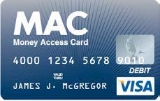
Enroll today at www.jetpaycard.com

Money Access Card “MAC” Visa® Prepaid Card

Choose MAC for yourself or get MAC for a family member.

With or without a bank account, MAC is for everyone.

- Employees – sign up for direct deposit and eliminate high check cashing fees

- Spouses – your spouse can get their own account
- Students – students can add wages or parents can add money from a checking account
- Budgeters – budget everyday expenses and avoid overspending
- Savers – have safe place to put money aside for that special purchase
- Parents – sign up yourself and your young adult age 16 and up
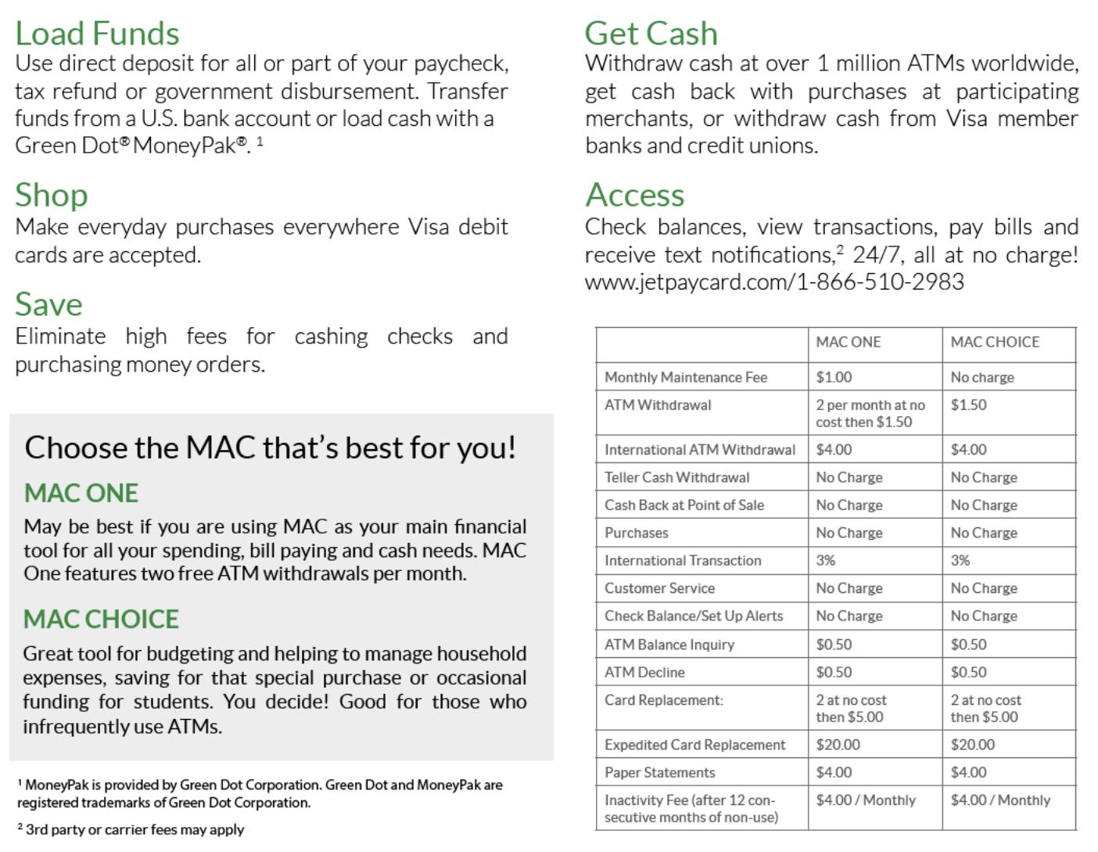

This Card is issued by Metropolitan Commercial Bank, Member FDIC, pursuant to a license from Visa U.S.A. Inc. “Metropolitan Commercial Bank” and “Metropolitan” are registered trademarks of Metropolitan Commercial Bank. Use of this Card is subject to the terms and conditions and applicable fees of the Cardholder Agreement from Metropolitan Commercial Bank, as issuer.

USA Patriot Act Disclosure. Important information for opening a card account: To help the federal government fight the funding to terrorism and money laundering activities, the USA PATRIOT Act requires all financial institutions and their third parties to obtain, verify and record information that identifies each person who opens a card account. What this means for you: When you open a card account, we will ask for your name, address, date of birth, and other information that will allow us to identify you. We may also ask to see your driver’s license or other identify documents.

2

JetPay Payroll Service | 3939 West Drive | Center Valley, PA 18034

P. 610.797.9500 1-800-DO MY PAY ® (366-9729) F. 610.797.9520

