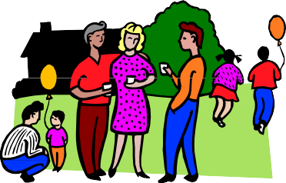

**JUST A FRIENDLY REMINDER OF OUR NEIGHBOURHOOD**

**BLOCK PARTY**

**“Keeping the “U” in Neighbourhood”**

Date:

Time:

Place:

**Remember, we are asking each family to bring:**

* Salad, dessert or condiments (please bring enough for 6 people)
* Beverages for your family
* Non-breakable plates, cups and cutlery for your family
* Chairs for your family to sit on

Hot dogs, hamburgers, buns and condiments will be supplied.

If you have any questions, please contact:

***Come out and have some fun, meet your neighbours!***