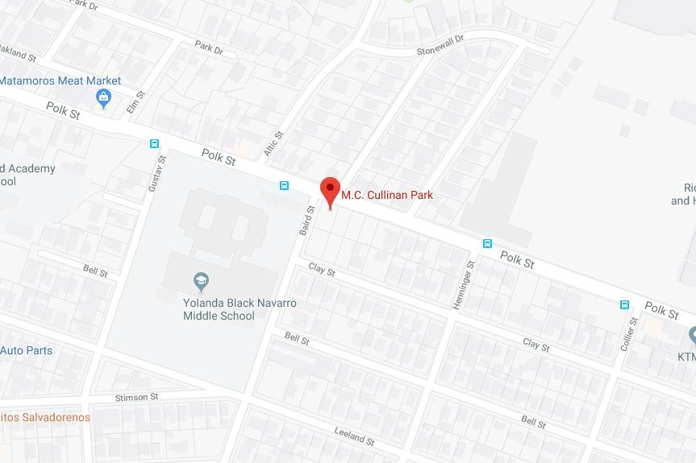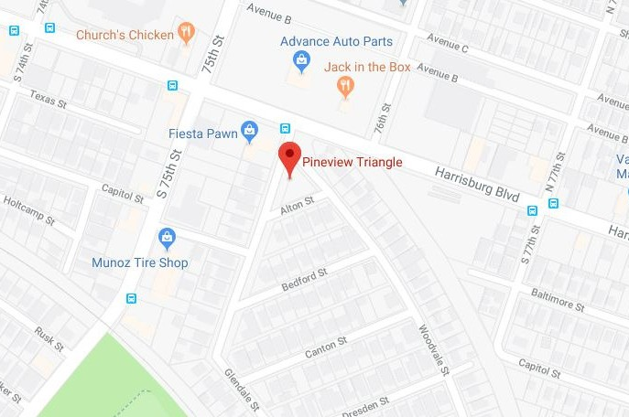

**FREE! FREE! FREE!**

BLOCK PARTY

**11 AM to 2 PM**

**MEET YOUR NEIGHBORS & ENJOY FOOD, GAMES, COMMUNITY & ART**

*If you can, bring a dish to share!*

**E A S T E N D B L O C K P A R T Y . O R G**

PINEVIEW PLACE

2 ND SATURDAY OF THE MONTH

PINEVIEW TRIANGLE 101 ALTON ST

EASTWOOD

1 ST SATURDAY OF THE MONTH

MC CULLINAN PARK 5120 POLK ST