Welcome to

Welcome
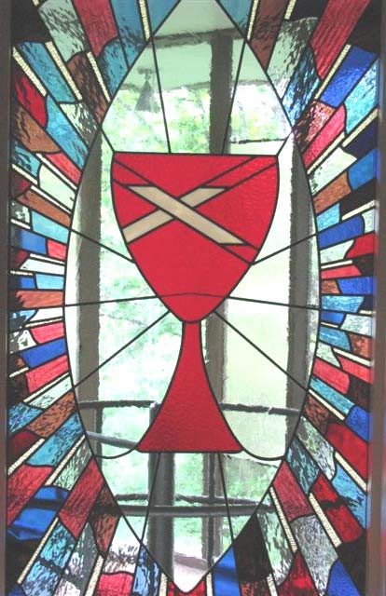

*Call to Worship
Leader: We are on a journey of faith following Jesus, our guide.

People: We place our trust in him and follow.
Leader: As the daylight hours grow longer, our journey takes on an urgency.

People: He is preparing our hearts for Jerusalem.
Leader: Fear not! God is with us and will guide us on this journey of faith.

People: We place ourselves completely in God’s care.
*Song of Praise “Morning Has Broken” Red #53
*Opening Prayer Children’s Moment

Lake Washington Christian Church

Greetings! In the name of Christ, welcome. After worship please join us in the foyer for coffee and conversation.
Young children may remain in worship or their parent may take them to the Koinania Room.
A quiet activity packet is available for school-age children
Ritual of Friendship
Special Music “Lonesome Valley” Choir Prayer for Illumination “Listen to the Word”
Listen to the word which God has spoken; Listen to the One who is close at hand; Listen to the voice behind creation;
Listen even if you don’t understand.
Scripture Matthew 22:1-14
Sermon “What a Party”
Time of Reflection
Sermon Hymn “Out of the Depths” Red #510
* Please stand as you are able

Prayers of the People & Lord’s Prayer (Sung) Red #310
Helpful Information for Guests
Welcome in the name of Christ. Your presence is important to us and we hope you will feel comfortable here. If this is your first visit with us we in- vite you to fill out the attendance sheet that will be passed during our “Ritual of Friendship.”
If you are worshipping with children they are welcome to sit with you during the service, participate in our Children’s Moment, spend time in our nursery, or attend Sunday School for their age group.
As part of the Christian Church (Disciples of Christ) we celebrate commun- ion every Sunday. We practice “Open” communion, which means all are in- vited and welcome to share in the Lord’s Supper. You do not have to be a member of this church or denomination to be welcome at this table.
As a member of God’s family you are welcome here! Let us know what we can do to make you feel at home!
Affirmation of Faith On Wall
Invitation to Stewardship Offertory Music
*Response “Give Thanks” On Wall
Communion Meditation
*Communion Song “This Is the Place” Purple #160
*Prayer for Bread and Cup Words of Institution
Partaking of Bread and Cup Intinction
(To remove all barriers to participation,
non-alcoholic & gluten-free communion is offered.)
Prayers of the People
Prayers for family and friends who are dealing with loss, illness, and other life-changing events. Peter, William and Matt
Prayers for Peace and Comfort in our country and world. May the voice of love and justice be heard everywhere.
Prayers for our partners: Estonia, Latvia & Lithuania; East Side Christian Church in Tacoma and their pastor; and Holy Spirit Lutheran Church and their ministers and min- istries.
Prayer of Thanksgiving
Song of Discipleship “Christ Be Beside Me” On Wall Announcements
*Blessing
*Sending Song “The Lord Bless and Keep You” On Wall Please join us for refreshments and fellowship following service.
Serving Today
Rev. Kara Markell Dick M.
Mike L. & Shelly M. Toni L.
James S.
Preacher Elder Deacons Reader Music
Lake Washington Christian Church
Sermon Notes:
343 15th Ave
Kirkland, WA 98033-5508
Phone - 425-822-4637
Email - office@lwchristian.org Website - www.lwchristian.org

