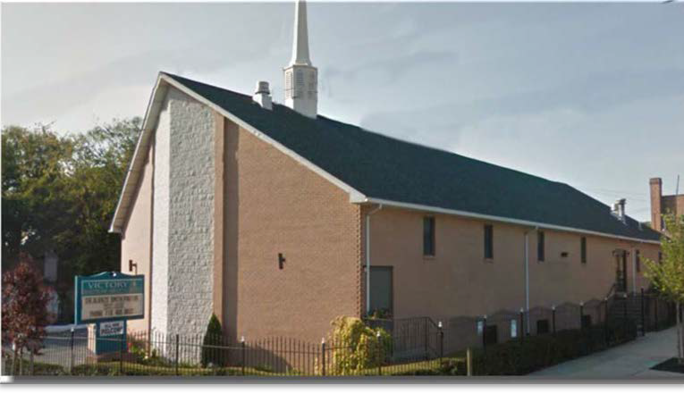
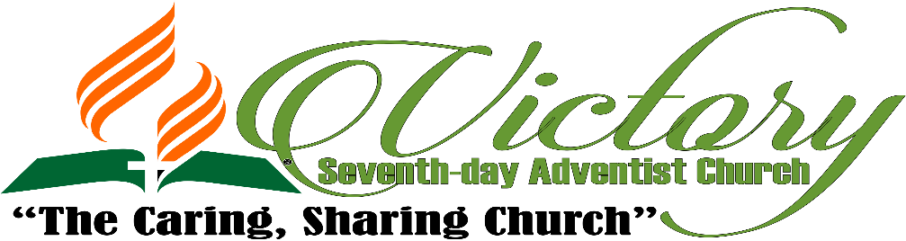

Sabbath, May 5, 2018
“THE ARMENIAN MINDSET”
Lew Keith;
President of Butler Creek Health Education Center
Learn to do good; seek justice, correct oppression; bring justice to the fatherless, plead the widow's cause.
Isaiah 1:17

WELCOME TO OUR GUESTS!
1271 Burke Avenue, Bronx, NY 10469. Phone: (718) 405-0632 Fax: 347-899-8211
E-mail: victory_sda@hotmail.com|Website: www.victorysda.org|
Live Streaming: vsdabn.org

CHURCH IN SERVICE
On Duty Today
Platform Coordinator Elder Miriam Smith
Church Clerk Sis. Monique Appleton
On Duty Everyday
Pastor Dr. M. G. Gregory: mgmilory@gmail.com|914-572-1611 Associate Pastor Albert B. Peterson II: peterson.albert@yahoo.com|412-608-6220 First Elder Leslie Pitterson: lcpitterson@gmail.com|914-473-7912
Head Clerk Eric A. Thomas: eathomas18@hotmail.com|917-291-3225
Head Deacon Deacon Colville Fraser
Head Deaconess Deaconess Sheena Belle
Adventist Youth Director Sis. Monique Fraser
Communications & Multi-Media Leader Elder Barrington Anderson Community Services Leader Sis. Claudette Hall
Health Ministries Director Sis. Lorraine Bogle
Family Life Ministries Bro. & Sis. Horace Appleton
- Men’s Ministry Bro. Eric A. Thomas
- Women’s Ministry Sis. Myrna Harris
- Singles' Ministry Sis. Vernetta Collins
Pathfinder Director Sis. Gabrielle Francis
Personal Ministries Coordinator Elder Franklin Julius
Sabbath School Leader Sis. Barbara Humphrey
PASTORS’ VESTRY HOURS
TEL: (718) 405-0632, (347) 899-8210
Wednesdays, 6:00 PM –7:30 PM

During Vestry hours, the Pastor may do house visits; it is advised to call ahead just to ensure that he is present in the office.
VICTORY SEVENTH-DAY ADVENTIST CHURCH
MISSION STATEMENT
The mission of the Victory Seventh-day Adventist Church is to foster a nurturing, caring community of believers, united in proclaiming the gospel, within the context of the Three Angels Messages of Revelation 14: 6–12.
QUICK VIEW OF EVENTS CALENDAR!
APR.  MAY  MAY  MAY  MAY | HEALTH MINISTRIES HEALTHY LIFESTYLE SERIES - April 28 – May 5
 | MEN’S CONVENTION – May 4 – 6, 2018
 | WOMEN’S MINISTRY SECRET SISTER – May 5th at 8pm
 | CHILDREN’S DAY/MOTHERS’ DAY CELEBRATION – May 12, 2018
 | ENGLISH MINISTRY CONVENTION – May 19, 2018
THE CHURCH AT STUDY
SABBATH SCHOOL - 9:15 AM - 10:40 AM
Song Service Opening Song Opening Remarks Prayer
Scripture Reading Mission Emphasis
SABBATH SCHOOL LESSON REVIEW
Welcome Special Music Closing Remarks Closing Hymn
PERSONAL MINISTRY – 10:40-10:50
Closing Prayer
* A.Y.M. SERVICE – 5:00 PM
Song Service Prayer
Scripture Reading
AY Aim / Motto / Pledge & Song Welcome

EVENING’S PROGRAM

AIM: The advent message to all the world in my generation.
MOTTO: The love of Christ constrains me.
PLEDGE: Loving the Lord Jesus, I promise to take an active part in the work of the Adventist Youth Ministry, doing what I can to help others and to finish the work of the gospel in all the world.
SONG: Adventist Youth are we from every land and sea.
Together we pray and work and play in happy harmony. We have a faith to share with others everywhere. A message of love from God above to show the world we care. Adventist Youth! Adventist Youth! Adventist Youth!
* VESPERS SERVICE
[At Sunset - before AY during EST and after AY during DST]

THE CHURCH IN WORSHIP
11:00 AM - 1:00 PM
WE ENTER TO WORSHIP
Prelude {# 692 - “The Lord Is In His Holy Temple”} Praise Team/Choir/Organist Introit {Platform Party enters} “All Hail The Power of Jesus Name” Congregation Call to Worship Elder Miriam Smith
Doxology “Praise God From Whom All Blessings Flow” Congregation Invocation Bro. Lew Keith
Affirmation of Faith Fundamental Belief # 16 Elder Miriam Smith Mission Statement Congregation
WE FELLOWSHIP & PRAISE
*+Welcome “The Health Song” Sis. Lorraine Taylor-Bogle
Pastoral Emphasis Dr. M. G. Gregory
Members Support Offering
Praise & Worship Praise Team
OUR WORSHIP AND STEWARDSHIP
+Opening Song # 614 “Sound The Battle Cry” Congregation
*Introduction to Prayer “Trust Me” Congregation
+Intercessory Prayer Elder Edwin Wiggan Response “Hear Our Prayer O Lord” Congregation Children’s Story “Let the Little Children Come” Pastor A. Peterson II
+Tithe & Offerings Sis. Joan Russell
Response "We Give Thee But Thine Own” Congregation Special Music Call To Praise
+Scripture Reading Isaiah 1:17 Bro. Joshua Davis
Introduction Elder Ayon Bright
Meditation Call To Praise

THE SPOKEN WORD Bro. LEW KEITH
“THE ARMENIAN MINDSET”

Closing Hymn # 316 “Live Out Thy Life Within Me” Elder Ayon Bight Benediction Elder Ayon Bright
Response # 214 – We Have This Hope” Congregation Recessional Organist
Thank you for worshiping at the Victory Seventh-day Adventist Church. If you are visiting for the first time we pray the worship activities will enrich you spiritually. Congregation, as your act of reverence for God’s Sanctuary, please wait to be ushered from the Sanctuary by the Ushers; refrain from loud talking or other activities which are not suitable for the Sanctuary and do have a gracious and blessed coming week. Happy Sabbath!

IN THE SPIRIT OF WORSHIP

PLATFORM PARTICIPANTS

Platform participants are to meet with the presiding Elder in the Conference Room at 10:45 AM
+ Indicates that Participant seated on the platform will exit the platform once he/she has completed the worship service assignment.
- Please remain alert to the part you have to play in the service. Be prepared to do so with dispatch.
- Please speak directly into the microphones.
- Please do not turn microphones off; they will be muted by the audio booth.
- Please do not tap microphones!
CONGREGATION
* Indicates that Congregants may be seated at this time as directed by the Ushers.
- Congregation, please mute or turn off all cell phones.
- Be aware that we broadcast our services live. Please refrain from any movement, activity or conversation which may transmit unfavorable message to our online guests and others!
- During the Services, please try to refrain from exiting and entering the Sanctuary during the Intercessory Prayer, Prayer Response, Meditation, Offertory, and Special Music. If you must do so, please exit or enter as discreetly as possible.

Please help keep the church building in a manner befitting God’s House. Please do all you can to keep it and its furnishings in the way God expects us to and refrain from excessive noise in the Sanctuary always!
Kindly leave the sanctuary in a reverent manner. All conversation should take place in the foyer or in the fellowship hall after the service.

Fundamental Belief # 17 – “SPIRITUAL GIFTS”
God bestows upon all members of His church in every age spiritual gifts that each member is to employ in loving ministry for t`he common good of the church and of humanity. Given by the agency of the Holy Sp` irit, who apportions to each member as He wills, the gifts provide all abilities and minis`tries needed by the church to fulfill its divinely ordained functions. According to the Scriptures, these gifts include such ministries as faith, healing, prophecy, proclamation, teaching, administration, reconciliation, compassion, and self-sacrificing service and charity for the help and encouragement of people. Some members are called of God and endowed by the Spirit for functions recognized by the church in pastoral, evangelistic, and teaching ministries particularly needed to equip the members for service, to build up the church to spiritual maturity, and to foster unity of the faith and knowledge of God. When members employ these spiritual gifts as faithful stewards of God’s varied grace, the church is protected from the destructive influence of false doctrine, grows with a growth that is from God, and is built up in faith and love. (Acts 6:1-7; Rom. 12:4-8; 1 Cor. 12:7-11, 27, 28; Eph. 4:8,
11-16; 1 Tim. 3:1-13; 1 Peter 4:10, 11.)

ANNOUNCEMENTS
TODAY – MAY 5, 2018
CHILDREN'S BIBLE TIME: Today at 3:30 PM
BIBLE CLASS: Today at 5:00 PM
ADVENTIST YOUTH MINISTRY(A.Y.M): Today at 6:00 PM
CHILDREN’S MINISTRY: Parents and children are asked to meet by the Organ immediately following Divine Service.
TOMORROW – MAY 6, 2018
PRAYER MINISTRY: Meets 6:00 AM here at Victory. Let us be united in prayer. Bring someone with you.
NEXT WEEK'S EVENTS
SUBMISSION OF ANNOUNCEMENTS: The deadline for all announcements and inserts for the weekly printed worship program is no later than WEDNESDAYS of each week. Information should be emailed to victory_sda@hotmail.com. Announcements or inserts submitted after this date WILL NOT BE INCLUDED.
RECURRING EVENTS
COMMUNITY SERVICES DEPARTMENT: Hot meals are served every Sunday to the community and shut-ins, from 10:30 AM to 1:30 PM
UPCOMING EVENTS
WOMEN'S MINISTRY: Ladies participating in the “Secret Sister” program are reminded that the revealing date is today May 5th in the Fellowship Hall immediately after sunset.
HEALTH MINISTRIES: National Diabetes Prevention Program has begun. April 28th. Today during the Bible Class hour there will be a program that focuses on STI’s with Adults.
CHILDREN’S MINISTRY: Please support the children of Victory as they lead out on Children’s Day, May 12th. Girls attire should be full yellow, and boys should wear yellow shirt and gray pants.
CARE PACKAGES
CARE PACKAGES: Members are asked to contribute care packages for the Operation HOPE ministry. Items needed are such as toiletries, socks, male and female undergarments and other necessities.
BEREAVEMENT
Please remember in your moments of prayer members of our church family who have experienced the loss of their loved ones. Remember also Bro. Kenroy Barrett, Sis. Diana Francis, Sis. Karen Stoddard and Sis. Paula Samuels who experienced recent losses.
VAN MINISTRY (Operation H.O.P.E): Meeting every first Tuesday of the month;
ANNOUNCEMENTS
MAY BIRTHDAYS
BIRTHDAYS: 3rd – Crecencia Adams; Mcaylah Dixon; 7th – Tamar Douglas; 8th – Lenford Dell, Onisha Fennell; 17th – Trevicia Ward; 19th – Audrey Smith- Malcom; 22nd – Franklin Julius; 24th – Eulalee Mattis, Loye McClean; 29th – Marquise Morrison; 30th – Jamar Eccleston;

WEDDING ANNIVERSARIES: 6th – Bro. & Sis Myers

- LET’S GET PHYSICAL & HEALTHY
Exercise classes continue every Monday and Thursday from 7:00 PM - 8:00 PM in the fellowship hall. The program is now directed by Victory’s fitness trainers who were trained by the NYC Department of Health.
* SICK AND HOME MEMBERS
Please call or visit: Please call or visit: Sis. Lucita Gordon, Marcia Williams, Maureen Campbell, Daphne Isaacs, Paulette Newman, Coragine Bachelor, Novelette Maitland Bros. Romel May – 347-495-5808, Benoni Harris – (Kings Harbor Nursing Home) 718-379-5138, Jocelyn Isaacs – (Bay Park Nursing Home), Reuben Donovan.
* PRAYER LIST
PLEASE CONTINUE TO KEEP IN YOUR PRAYERS: Bros. David Willis, Cleveland Pearce, Jieraun Benjamin (US Navy), Julian Benjamin (US Air Force), Vaughn Davis (US Army), Carlton James Jr. (US Marine Corps), Oliver Qutel (US Marine Corps).
Sis. Jhenelle Bryan (US Air Force), Kris-Ann Foreshaw (US Navy).
FELLOWSHIP LUNCHEON
PLEASE DINE WITH US AT OUR FELLOWSHIP LUNCHEON RIGHT AFTER DIVINE SERVICE.

Next Sabbath Will Be Our Potluck Luncheon.
SUNSET CALENDAR
Today, Sabbath, May 5th, 2018 – 7:56 PM Next Week Friday, May 11th, 2018 – 8:02 PM

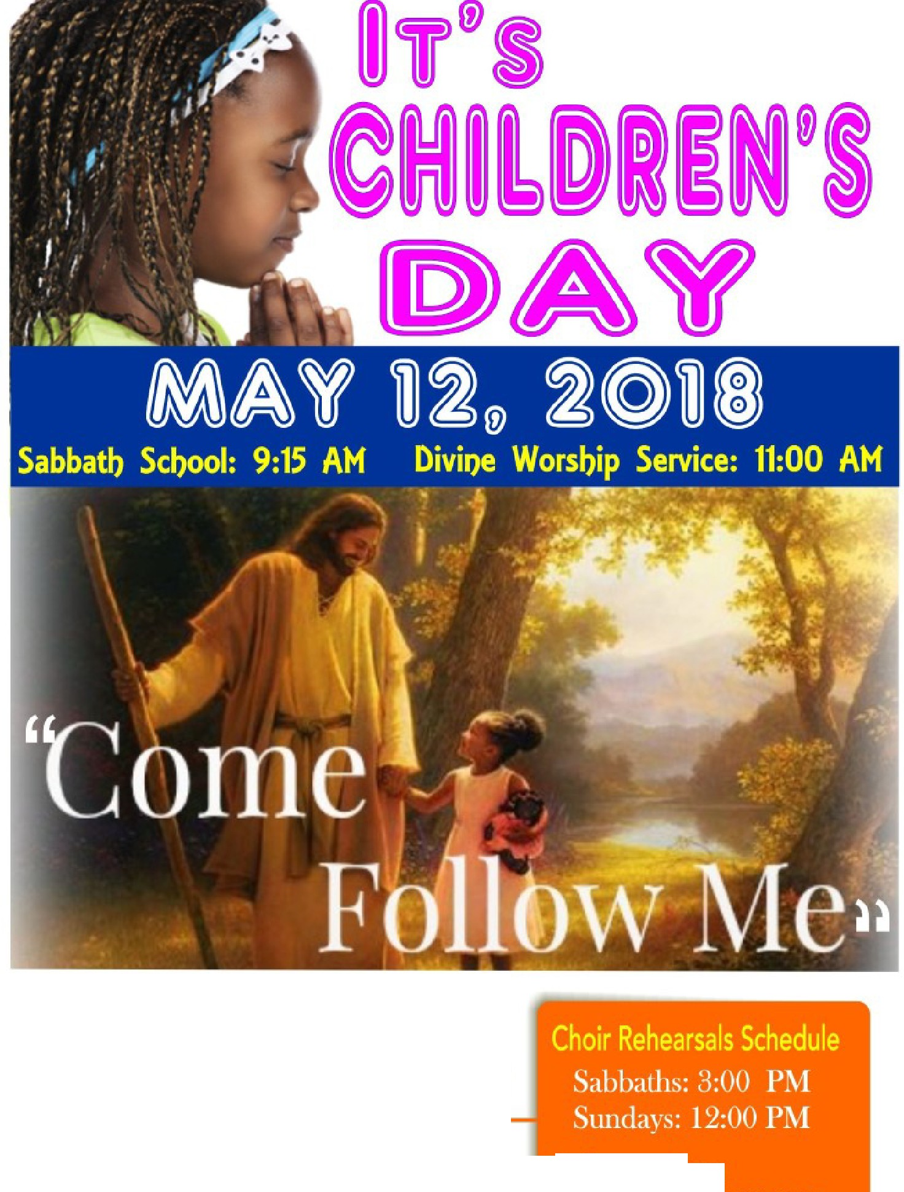
iribute 6J
To @ 6:00 PM

CELEBRATION COLORS:

GEm.s "Y l,LOW
BOYS ,. GRIEEN 8c YELLOW

Information
Sis. J. Adams - 718-909-2113
Sis. M. Pilterso11 • 914-664-6352
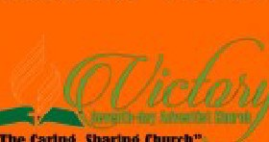

Pub li sh ed by t he Commun ica ti on Min is try or V i c tor y Sevent h- day Adventi s L Chu 1: ch

MOTHEltS DAY
COMMUNITY ESSAY WRITING CONTEST
5ponsored b.':I t he Women's Minis t':l of the Victor.':! 5 eventh -da.':I Adventist Church

  - ?Ufio: ;43es G-153ears
  - 'J-fow: Submit 200-300 wortfs esm3
eff faini»J why3our mother/mom/
mamaisspecial
if 'En{"J .Submission,I4.prif₁₅₋ MCI!) 6[/,,2.018

E_ntrie ma.':I be droppedoff duri ng the
( mom unit.':l 5 eivice Meals f rogrma on
5 u nda.'JS from I O AM to I fM at the
- 11.Jinmrre11eafd'M«3 f2.«f 6 'PM, whtrtesSllywiff6ertatf royurmotkr Victor!! Se venth-da!J A dvent is t
- 'Three fina«suw;{(6e cf.mm anl6e rteifimfs of srea,ltrizes afo"!J wi{h Ch urch located at I 27 I 5 urke A venue'
!heir mofhtr. f) ronx, NY I o+69

'Evuyone3efr a prize.I
- 'For further info caff:718.687,6493

i fllijJ
Or ema il !J0ur essay to:

eme ralddon egal@gma il.com

Puhl i shed by the Communica t ion Mi n is tr y of V i cto ry Seven th- day Advent i st Chu rch

tt c;REATER NEW YORK CONFERENCE, FAMILY AND YOUTH DEPArnM N s
r E INVITES YOU TO THE E T
,..:1111c11141,1011<dot✓ff)IC ofdttd� (_,,,01:f)Ie,5,5
K

11 l;l;PIN(; IT Rl;AL�''
- MEMORIES SPLASH RESORT. PUNTA CANA. DOMINICAN REPUBLIC -

-er27-80,2018

Ke note S eaker:
Dr. Hyveth Williams
Professorfrom Andrews University

Pa!:tor EverettSamuel 5.ngles Mif'Q'lesCootd,-iaro,
Pasto,AndmReye, Senoo<Paoo< Cano-dSD40un:h,Sarili.�

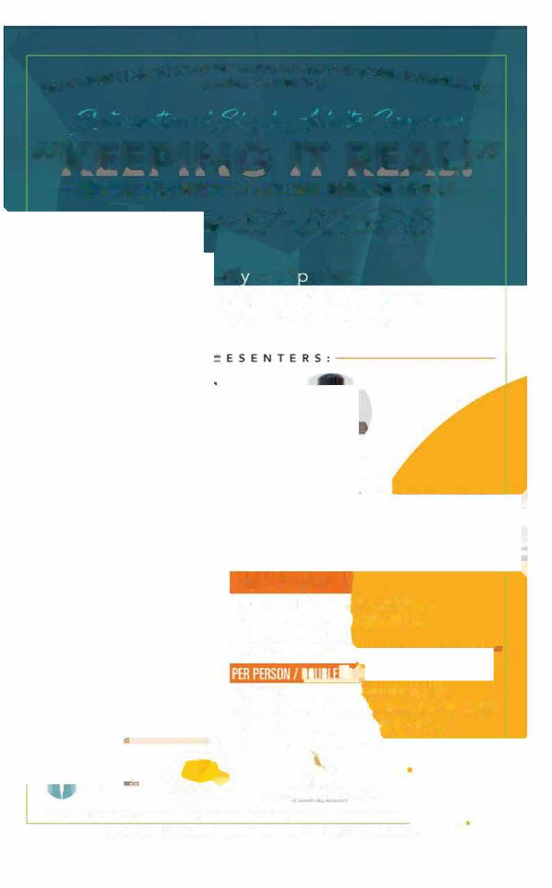
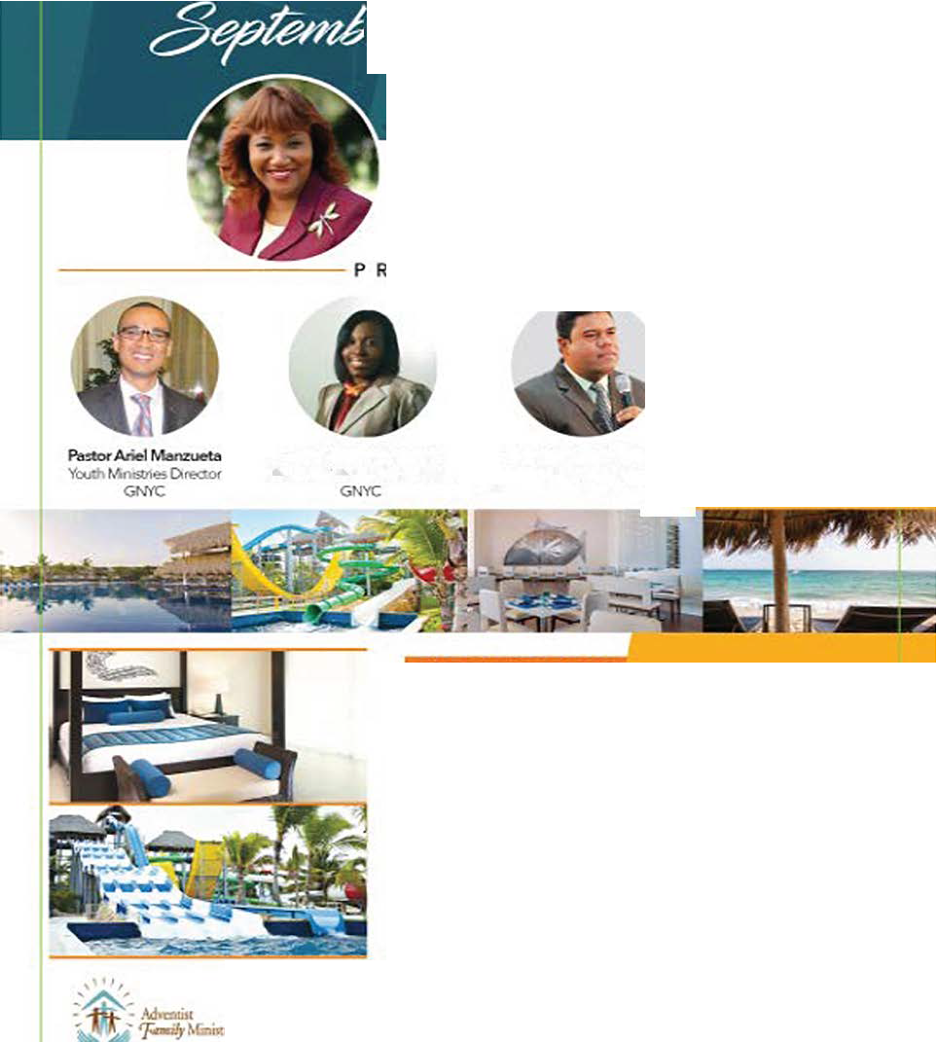

REGISTPATIOfi INll.UDES:

Admission ID all activities.selliws.1111 plmries 5 Stait all-inclllSive reSIII/ 3 lli1llls • 4 -,s Waref Part/ Polo slirt
IETIIUJW!STPIil:BYMADI,
11 I I�I

tfiS 379.00-falylle¢tatiooby111:ana31. 2017
lfi$419.00-&,lla �-Jaay lst-Maf 17.2018 If;$459.00-l.aleRe;sbM Imm� 18-ln:II Spa!2 is Lillitiid/�notiEklled

  - GKAnOKW�--=
FOR MORE INFORMATION OR TO MAKE YOUR RE SERVATION, CALL: CONTACT: KERR1ANN HAYMAN• EMAL: FAMILYMINJSTRIESOGNYC.ORG

SERMON NOTES

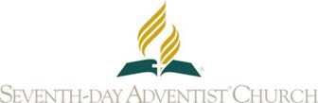
SEVENTH-DAY ADVENTISTS...
- Believe there is one God: Father, Son and Holy Spirit, a unity of three co-eternal persons.
- Accept the death of Jesus Christ on Calvary as the atoning sacrifice for sin and believe that by God’s grace through faith in His shed blood they are saved from sin and its penalty.
- Accept Jesus Christ as their Lord and personal Savior, and believe that God, in Christ, has forgiven their sins.
- Accept by faith the righteousness of Christ, their Intercessor in the heavenly sanctuary.
- Believe that the Bible is God’s inspired Word, the only rule of faith and practice for the Christian.
- Accept the Ten Commandments, including the fourth commandment, which requires the observance of the seventh day of the week as the Sabbath, as a transcript of the character of God and a revelation of His will.
- Look forward to the soon coming of Jesus and the blessed hope, and endeavor to help others to be ready for His glorious appearing.
- Accept the biblical teaching of spiritual gifts and believe the gift of prophecy is one of the identifying marks of the remnant church.
- Believe in church organization and purpose to worship God and support the church through their tithes and offerings and by personal effort andinfluence.
- Believe that the body is the temple of the Holy Spirit; and they honor God by caring for it, avoiding the use of that which is harmful, abstaining from all unclean foods; from the use, manufacture, or sale of alcoholic beverages, tobacco, narcotics or other drugs.
- Accept the New Testament teaching of baptism by immersion.
- Believe the Seventh-day Adventist Church is the remnant church of Bible prophecy and that people of every nation, race, and language are to be invited and accepted into its fellowship.

IMPORTANT SEVENTH-DAY ADVENTIST ORGANIZATIONS’CONTACTS

- General Conference of Seventh-day Adventists
12501 Old Columbia Pike, Silver Spring, Maryland 20904 USA Telephone: 301-680-6000 | Website: www.adventist.org
- Greater New York Conference of Seventh-day Adventists 7 Shelter Rock Road, Manhasset, NY 11030 USA Telephone: 516-627-9350 | Website: http://www.gnyc.org/
- Adventist News Network.
12501 Old Columbia Pike, Silver Spring, Maryland 20904 USA Telephone: 301-680-6000 | Website: https://news.adventist.org/en/
- G. C. Department of Public Affairs & Religious Liberty (P.A.R.L.)
12501 Old Columbia Pike, Silver Spring, Maryland 20904 USA

