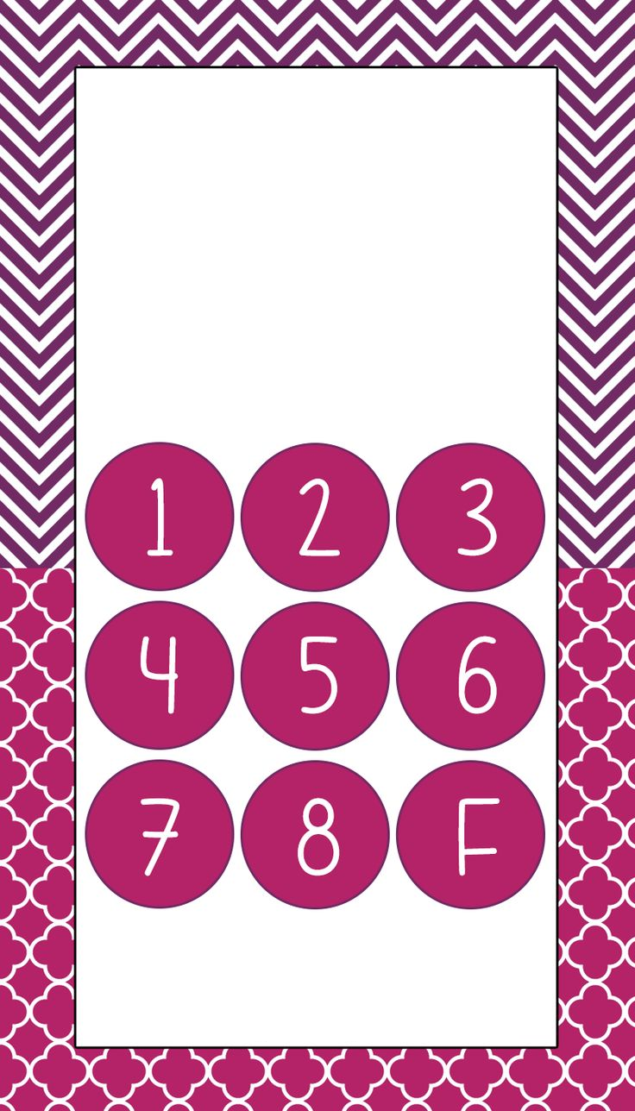

**phone77-777-77**

Compavy Name

Buy One & Get One Free

Address